# CS355 Databases

# Fall 2019

# Project Proposal

**Bootleg Steam**

Sabah Ismail (si03013)

Syed Affan Nemat (sn02236)

# *Submitted to*

Ayaz Hassan



Habib University, Karachi

Table of Contents

Introduction 3

**Modules of the System** 3

**Front-end Development** 3

**Tools & Technologies** 3

ERD 4

Interface 5

# Introduction

The PC games market has major stores like the Epic Games store and the Steam market. Our project will be an online game store, following some patterns form the two examples, where registered customers can order games online and download them onto their PCs to play with some key changes to the system to make the market places easier to use.

## **Modules of the System**

1. The system will have a list of games, each assigned a unique registration ID invisible to the user. Games will have a title, Developer Name, Genre, Price, cover image and Tags.
2. Customers will be registered on the system with a unique user address, name, their current account balance, list of games in library and a wish list.
3. Developers can register themselves and be assigned a unique developer ID. They will also have a studio name, list of developers and their designation, along with the studio's account balance. Developers must have at least one fully developed game ready for sale in order to register.
   1. There will also be a small difference depending on the type of developer they are e.g. Indie or AAA in the tagging system
4. Customers can search the games catalogue by using any of the criteria as mentioned in point 1. The user will see a list of games with their title, genre, tags and cover image. Upon selecting a game users will be moved to the game page where they can view other details and user feedback on the game along with other suggested games with similar tags or genres that the user may be interested in.

## **Front-end Development**

Web-based application with the following features:

1. Registration forms for customers and developers/publishers respectively.
2. Search fields and view functionalities.
3. Images and embedded video/audio
4. User Comment section and rating system
5. Difference in ability to edit product data based on type of user. Publishers/Developers can only edit data regarding their own product and Customers cannot edit data at all.
   * Admin users will also be added, they will only be able to edit everything and make forum posts and the like.
6. Users can only see some information regarding each other for the security of their personal information.

## **Tools & Technologies**

1. Back-end: MySQL or Oracle
2. Front-end: C#

# ERD

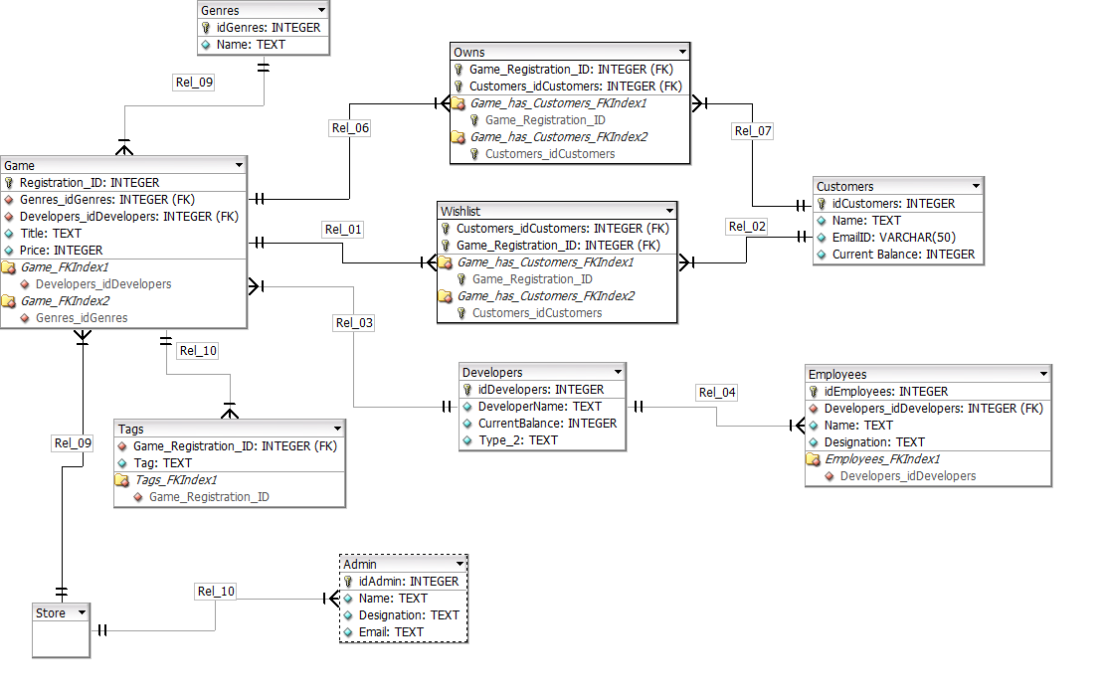

An initial version of this ERD didn’t contain the entities of “Store” and “Admin. This version of the ERD contains an entity for all present stakeholders and users involved. All entities will have different rights in the system and/or use given that each entity.

# Interface

Once the application is launched it will open to the home page that will display new games, information tabs, some news, the ability to login and register and a search bar.

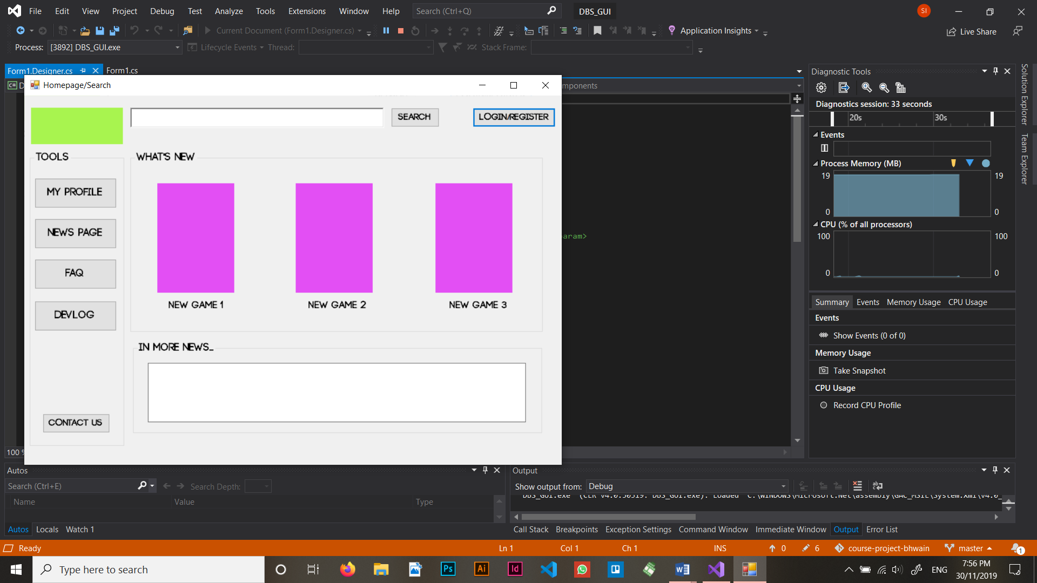

If you click the search bar without any input it is meant simply return the entire library of games. A grid-view system is to be implemented as well.

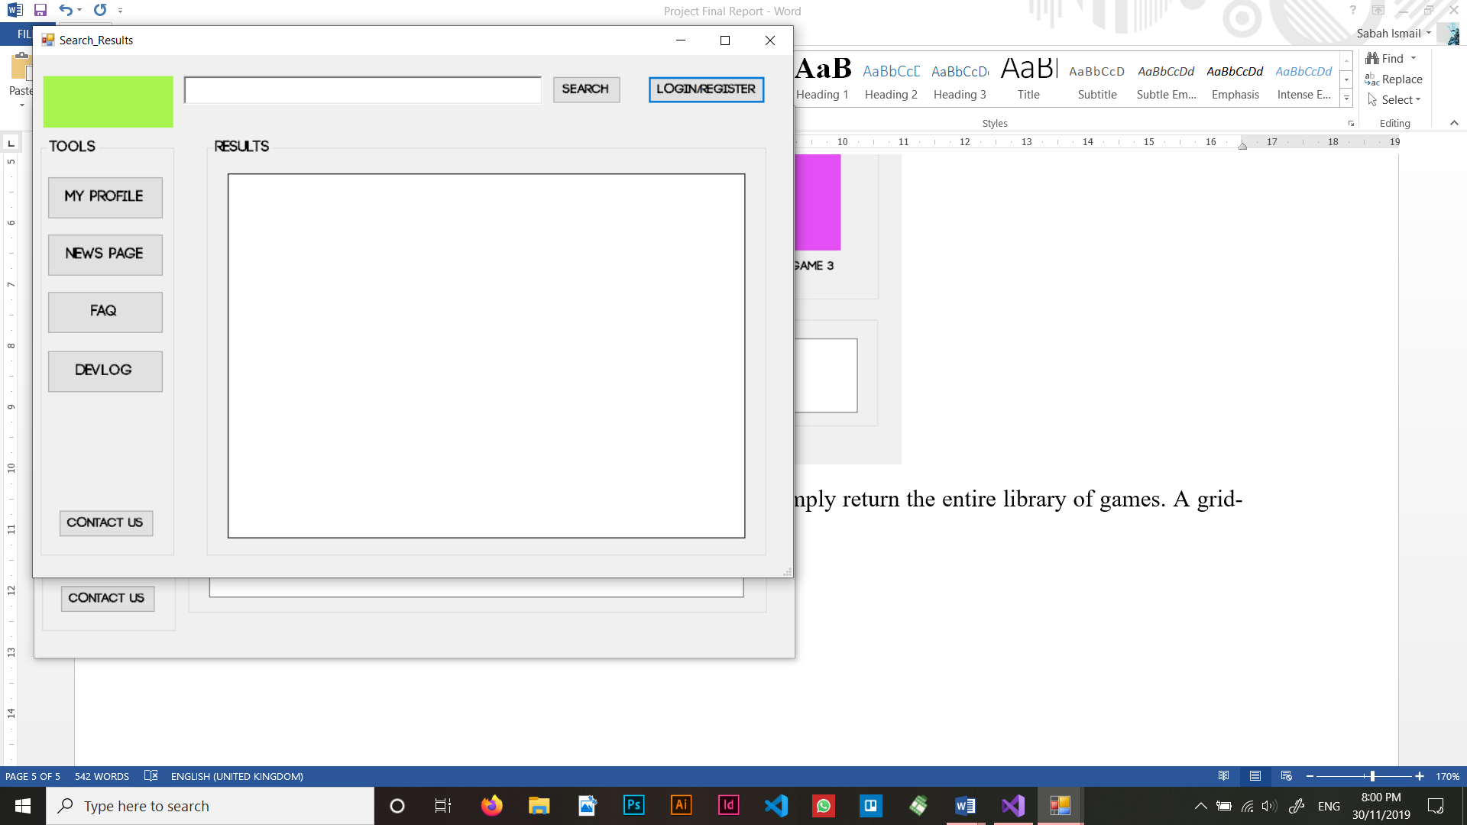

Clicking on one of the new games featured in the home-screen or in the search box will give the user the ability to view the details of each product. As shown in the image below. This instance allows for the ability to wishlist and purchase as well. clicking either option will add the list in the profile.

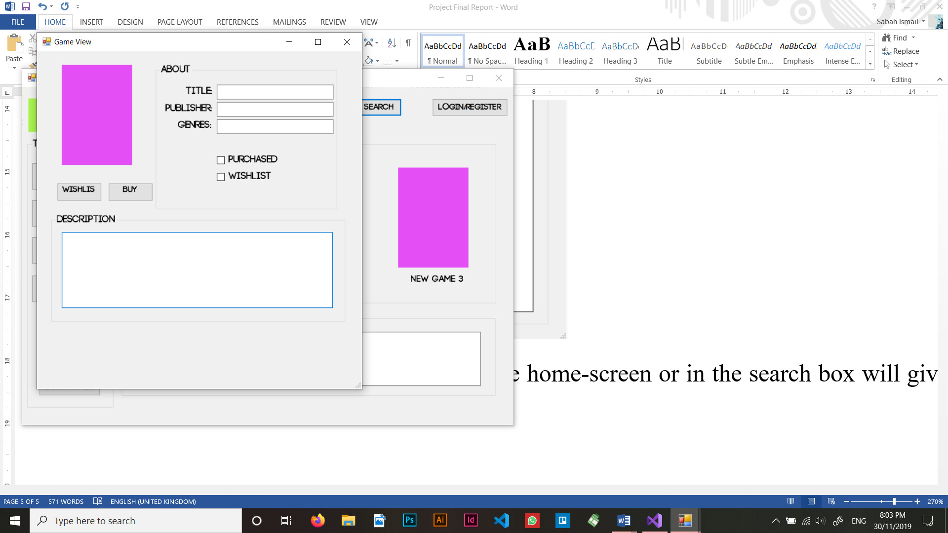

If you click the login/register option, you will be shown the login page.

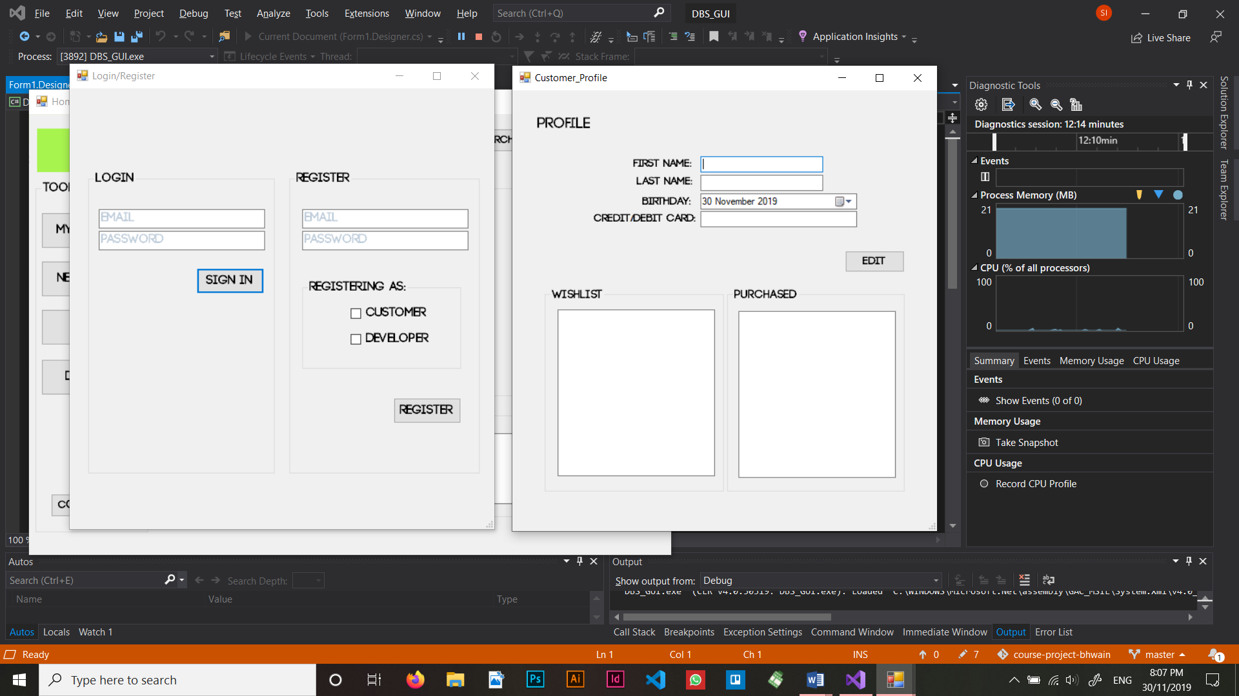

Once a user logs in, depending on the type of user they registered as, they will see one of three dashboards.

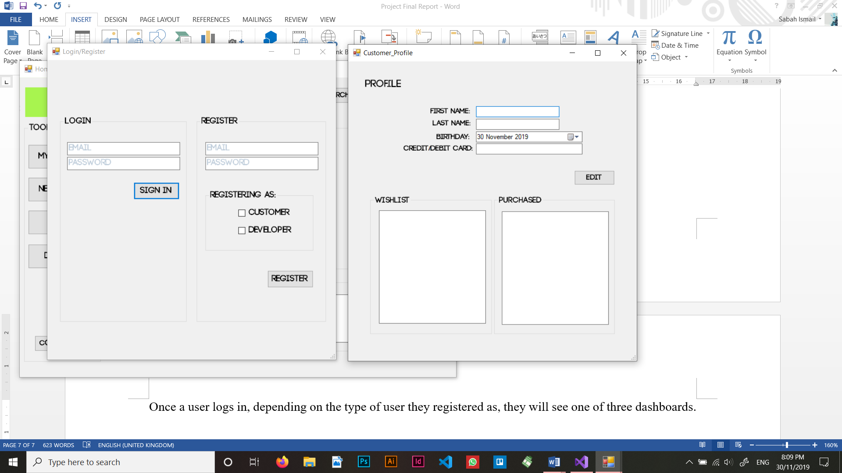

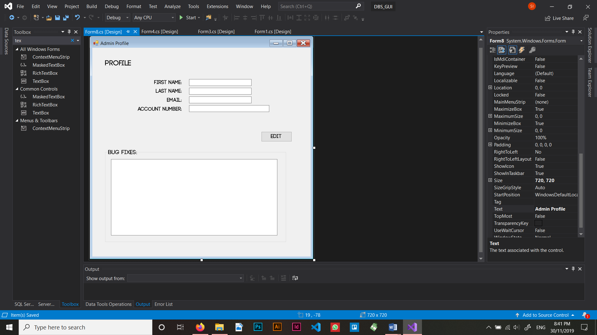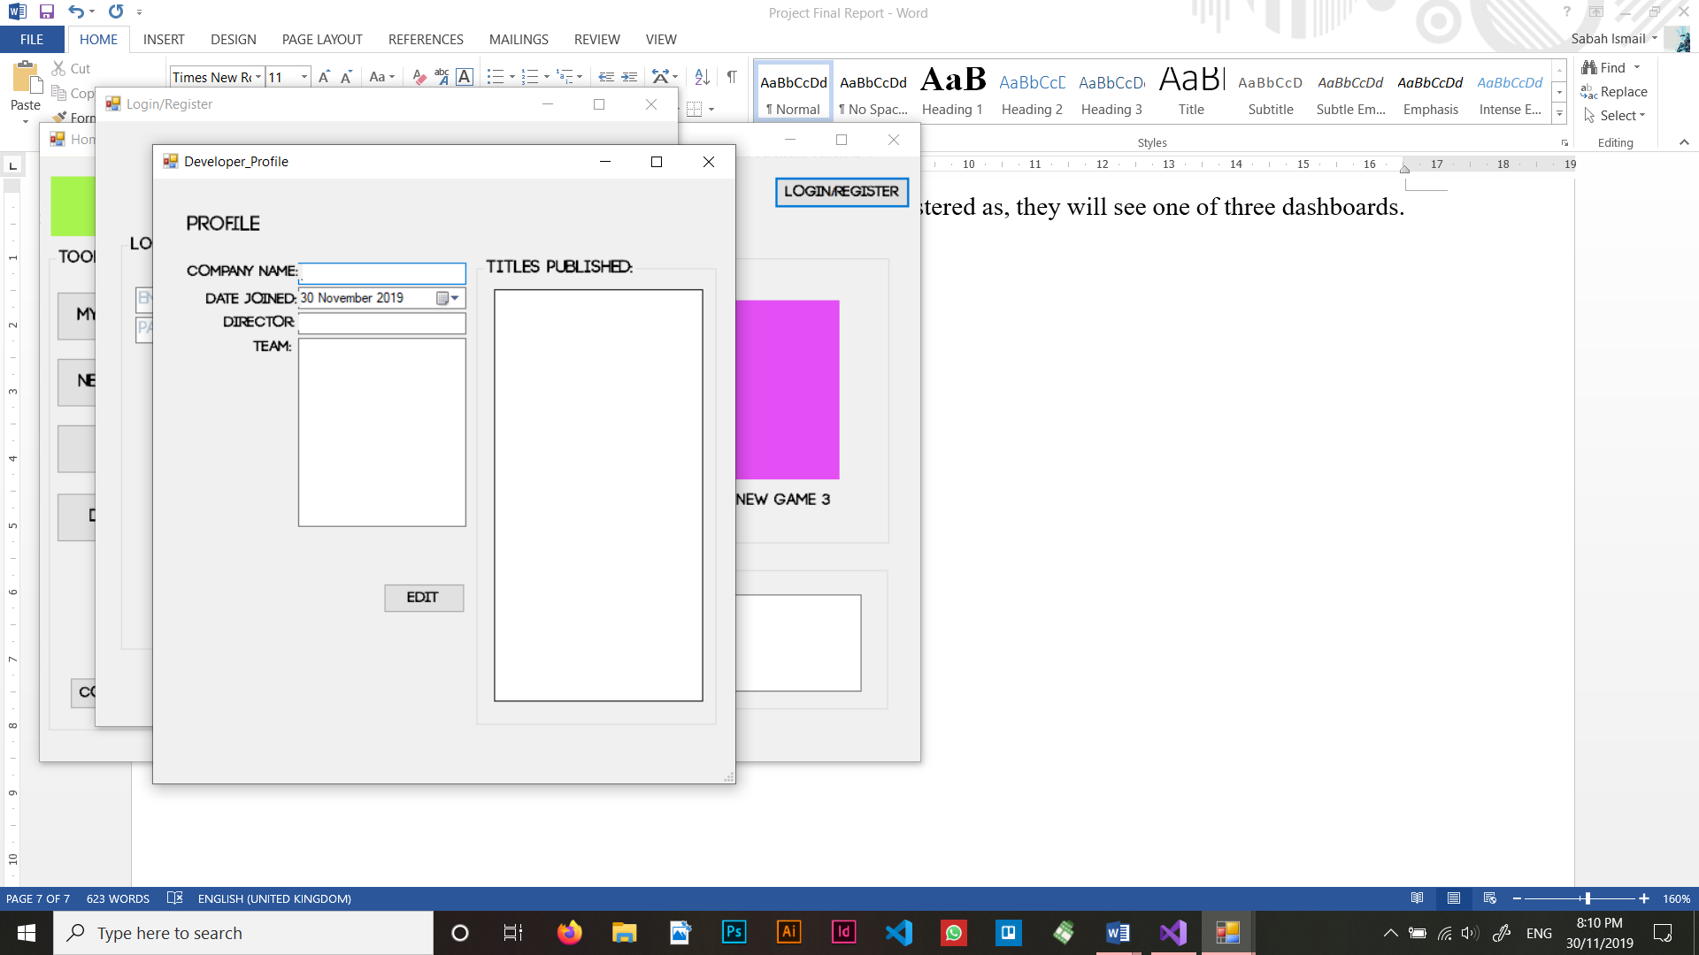

There is an edit option for all users and they will then see a corresponding edit information screen.

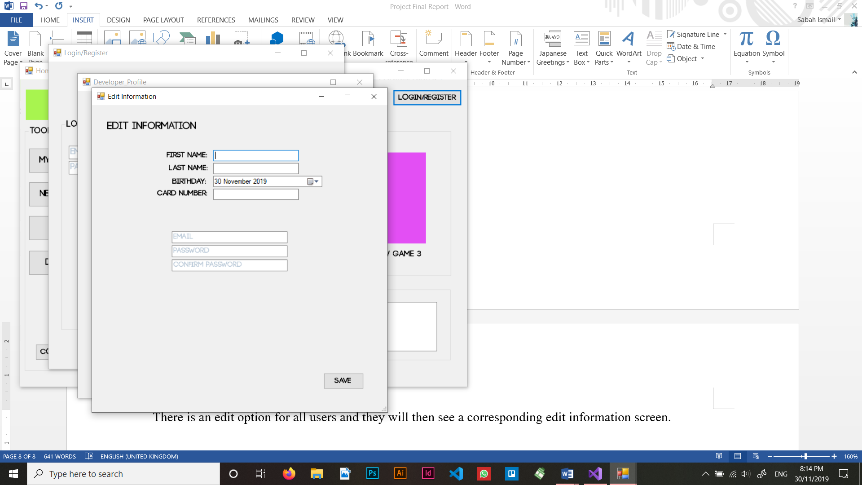

Upon saving the information the user will be redirected to the homepage.